FLOWERING PLANTS
These are plants that bear flowers. A typical flowering plant is composed of 2 systems i.e: Root system and Shoot system
The two systems are made up of two categories of organs i.e.
Reproductive organs: these produce fruits and seeds. They are directly involved in the reproduction of the plant.
Vegetative organs: these are not directly involved in the reproduction. They include roots, stems and leaves.

Structure of a flowering plant
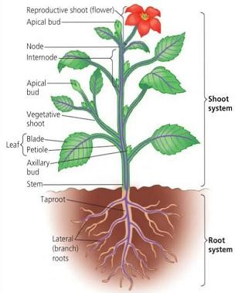

ROOTS
A root is a descending portion of the axis of the plant and develops from the radical of the embryo during germination.
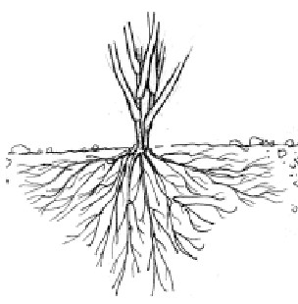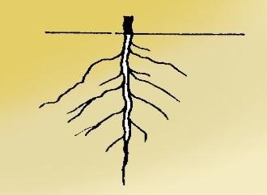
T
ypes of roots

1.

Tap root system

This consists of a main root growing straight down wards from the
radicle
. It gives rise to side roots called lateral roots. Tap root system is a
characteristic of dicotyledonous plants.

2.

Fibrous root system

This is the
root system without a main root and all roots arise from the
same point of the base of the stem
. The roots are almost of the same size
and a characteristic of monocotyledonous plants.

Functions of roots
- They anchor the plant firmly in the soil.
- They absorb water and mineral salts from the ground to the plant. iii) They conduct the absorbed water and mineral salts up to the stems and leaves. iv) In some plants, roots are modified into root tubers which store food e.g. cassava. v) Some roots are modified for breathing e.g. white mangrove.

MODIFIED ROOTS 1. Storage roots
These are thick fleshly and succulent roots. They contain stored food like sugar and starch. The roots are modified as root tubers e.g. carrots, cassava and sweet potato roots.

2. Breathing roots
These are found on some plants growing in swampy areas e.g. white mangrove. Its roots grow up through the mud to the air. The root parts above the mud are spongy and absorb air from the atmosphere. The main root of such plants bears branch roots.
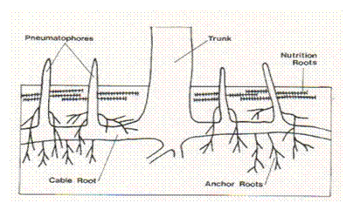

3. Stilt roots
These roots develop from the main stem in certain plants such as red mangrove which grow in muddy areas. Stilt roots provide additional support to the plant.
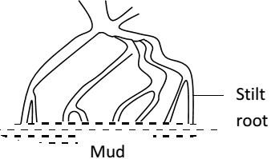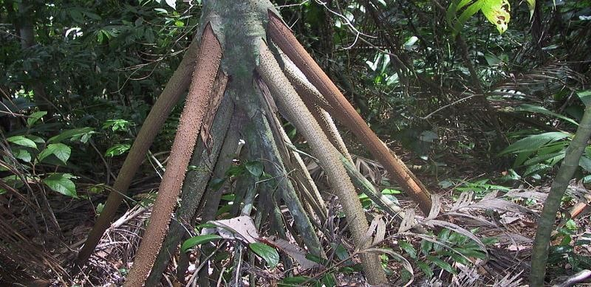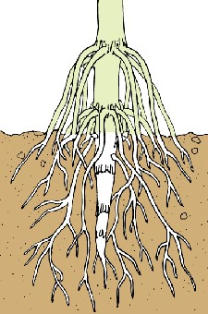

4.

Prop roots
:

These are found growing on plants such as
maize, sorghum and sugar
canes
. They develop from the nodes of the stem close to the soil surface.
They provide extra support by holding the plant firmly to the soil
surface.

5. Buttress roots
These are large thick roots growing from the base of certain stems e.g. Mvule trees, silk cotton, etc. They provide extra support to the plant by anchoring it firmly in the soil.
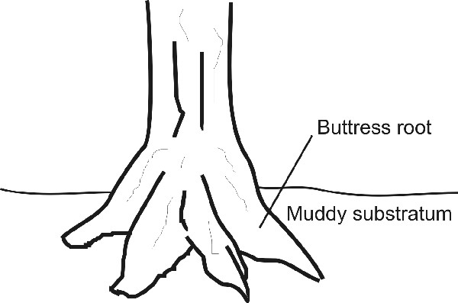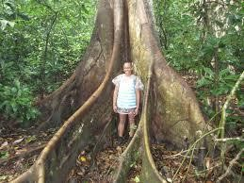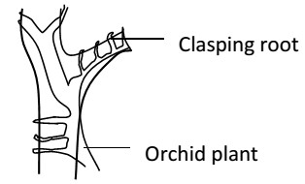

6.

Clasping roots

These are roots growing from the nodes of climbing stems such as
figs
(
mituba trees), vanilla and orchids.
They secret a sticky substance which
dries up in air.
This helps such plants to cling on to other plants for

support.

7. Epiphytic roots
These grow on certain plants called epiphytes. Epiphytes are plants which grow and get support from other plants. These roots hang freely in the atmosphere. They absorb moisture from the atmosphere.
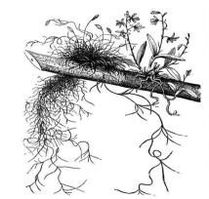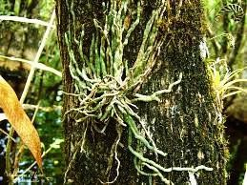

8. Sucking roots
These are roots found growing on certain parasitic plants e.g. figs (mituba). They grow from the stem and penetrate the host plant. These roots absorb water, mineral salts and organic food compounds from the host plant.

INTERNAL STRUCTURE OF A ROOT (LONGITUDINAL SECTION)
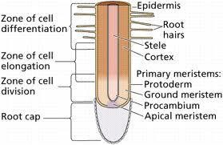
In a longitudinal section through the growing end of a root, its parts are divided into 4 main zone or regions:
- Root cap
- Region of cell division (meristematic region)
- Region of cell elongation
- Region of cell differentiation (maturation)

1) Root cap
This is found at the tip of the root and is made up of loosely arranged cells. It protects the tender apex of a root from mechanical damage as it makes its way through the soil. It’s absent in aquatic plants.

2) Region of cell division
This is the growing apex of the root lying just behind the root cap. The cells in this region undergo repeated divisions to form new root cap and new cells that increase the length of the root.

3) Region of cell elongation
This is the region lying just above the region of cell division. The cells in this region absorb water and develop vacuoles, the cells being elastic, elongated and enlarged. This causes an overall growth in the length of the root.

4) Region of cell differentiation
This is also called the region of absorption. The characteristic feature of this region is the development of root hairs; these are fine, delicate, unicellular hair like extensions of epidermal cells (periferous layer). They absorb soil water and dissolved mineral salts from the soil. The cells in this region acquire specific shapes and functions thus they are said to be differentiated or specialized.
NB: the region behind the zone of differentiation is the oldest part of the root. It has permanent tissues and is covered by a layer of cork which prevents the evaporation of water from the roots.

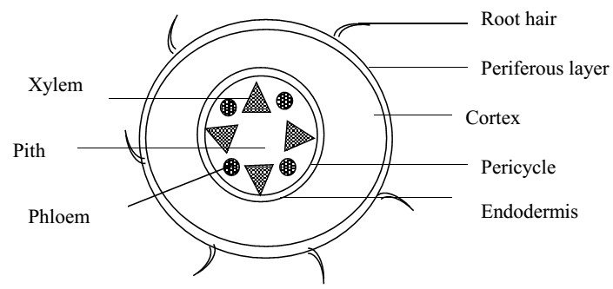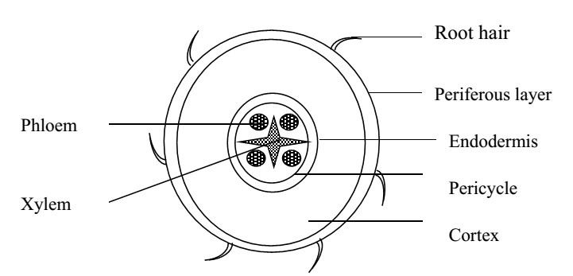
Transverse section of a root

Monocot root

Dicot root

The transverse or cross section of most young roots has two regions
- The outer cylinder (cortex)
- The central cylinder (stele)
The vascular tissues are composed of xylem and phloem and may contain cambium and pith tissues.
Xylem is the water conducting tissue through which water and mineral salts pass from the soil upwards to the stem and leaves.
Phloem is the food conducting tissue that carries manufactured food from the upper parts of the plant mainly leaves and distributes it to various parts of the root.
Cambium: causes secondary thickening of the root. It adds all secondary xylem cells on its inner side and secondary phloem cells on its outer side by continuous cell division during growing season.
Pith: is a small area in the centre of the monocot root. It is composed of parenchyma cells for strengthening the root. It’s normally absent in most roots because the centre is normally occupied by the xylem. It also stores food and water for the plant.

Differences between transverse section of monocot and dicot roots
 | Dicot root | Monocot
1. | Has no pith. | Has pith.
2. | Can form a ring of cambium. | Cannot form a ring of cambium.
3. | The xylem is star-shaped occupying the central part. | The xylem and phloem alternates forming a ring.

STEMS
This is the ascending portion of the plant axis that develops from the plumule of the embryo. It has the following characteristic features;
i) It bears leaves at the nodes. ii) It has nodes and internodes. iii) It has buds in the axills called axillary buds.
iv) It has flowers or fruits.
v) Its terminal bud is located at the tip of the stem. NB: the axill is the angle between the leaf and the stem.

Functions of stems a) Primary functions
i) They hold leaves in the best position for receiving enough sun light needed in the process of photosynthesis. ii) They conduct water and mineral salts from roots to leaves and manufactured food from leaves to other parts. iii) They hold flowers and fruits in good position so that they can be easily pollinated or dispersed. iv) When stems are young, they carry out photosynthesis thus making food for the plant. v) Stems have lenticels (pores) that facilitate gaseous exchange.

b) Secondary functions
- Some stems may specialize in storing food and water e.g. stem tubers like corms, Irish potatoes, rhizomes and sugar cane.
- Protect a plant against browsers by forming thorns, spines or prickles. iii) Vegetative reproduction or propagation through the stem cuttings e.g. cassava and sweet potatoes.
iv) They support the plant by climbing stem tendrils e.g. pasum pea (wild pea).

TYPES OF STEMS

1) Erect stems
These can support themselves in an upright position. They may be woody or herbaceous.
Woody stems: These have a high content of lignin and are hard. They are found in shrubs and trees.
Herbaceous stems: These contain no or less woody materials e.g. tomatoes, rice. The herbs are shorter than grass.
2) Weak stems
These can’t support themselves upright but either creep or climb for support.

3) Underground stems
These are modified stems which remain permanently underground. They are often swollen and serve as food storage organs.
NB:
- Annual herbs only live for one year
- Bi – annual herbs live for two years
- Perennial herbs live for many years

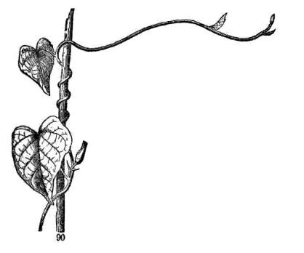
MODIFICATION OF STEMS

Weak stems

1.

Twinning stems (twinners)

These are stems that grow ascending spirally
around a support. They

are usually long and
slender e.g. Dutch man’s pipe and lianas.

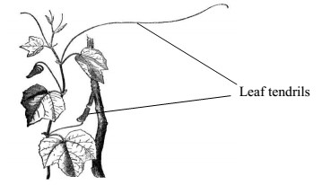
2.

Climbing stems

These are stems that grow clinging to the
support of other plants by means of tendrils.
Tendrils are thin wire
-
like spirally coiled
branches of certain stems. They may be
mo
dified at axillary buds e.g. in passion fruit
plants or terminal buds

3. Creeping stems (creepers)
These are long thin stems which grow along the surface of the ground, giving off roots at certain intervals of the nodes. Four types of creeping stems are; a) Runners
This is a slender trailing stem lying flat on the ground possessing long internodes. A runner arises as an axillary bud and creeps some distance away from the mother plant and grow into another plant e.g. oxalis.

b) Offset stems
This is a horizontal thickened short stem. It originates from the axil of the leaf and grows flat on the ground. It produces many leaves above and a cluster of roots below e.g. water hyacinth and water lettuce.

4. Sucker
A sucker is a creeping stem that grows obliquely upwards, directly giving rise to a leafy shoot. E.g. banana, pineapple, sisal plant, etc.

Underground stems
There are four types of underground stems namely: Rhizome, Corm, Stem tuber and Bulb.

1. Rhizomes
This is a horizontal thick underground stem having adventitious roots growing from the lower side of the nodes. It has terminal buds which develop into aerial shoots. It bears buds in axils of the reduced brown leaves called scale leaves.
Rhizomes store a lot food for the plant. Some also act as organs for vegetative propagation e.g ginger, canalily, couch grass and Solomon’s seal.
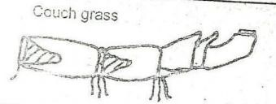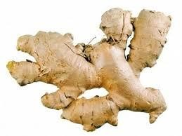

2. Stem tuber
This is a short, fleshy underground stem swollen with large amounts of stored food. It has scale leaves and axillary buds which form the “eyes” e.g Irish potato, yams.

3. Stolon
A stolon is a horizontally growing stem that roots at the nodes and develops buds that grow into new plants. E.g. straw berry.
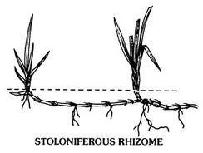

4. Bulb
A bulb is short conical-shaped underground stem comprising of thick fleshy leaves arranged in concentric circles. The thick fleshy leaves store food for the plant and are protected by outer dry brown leaves called scale leaves. A terminal bud lies at the top of the stem and give rise to the aerial shoot. Axillary buds are situated between the leaf bases. Onions, garlic, tuberose, etc. are bulbs.

Structure of a bulb (onion)
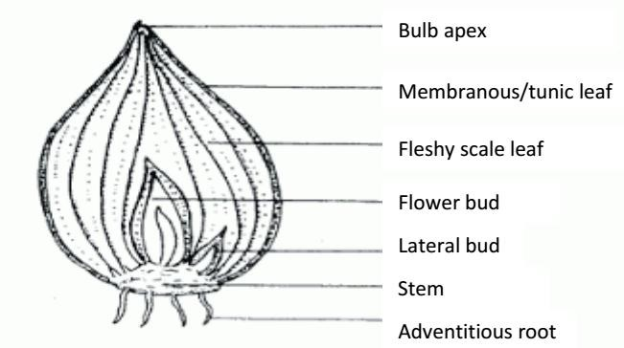

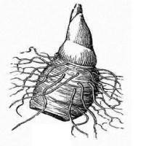

5.

Corm

A corm is a swollen fleshy underground stem that grows in a vertical
direction. It is round
-
shaped and somehow flattened from the top to
bottom. It
has a terminal bud lying at the top of the stem and has scale
leaves a rising from the nodes. Its roots grow randomly from the stem.
Examples of corms are coco

yams and yams.

INTERNAL STRUCTURE OF STEMS

Transverse section of a dicot stem Transverse section of a monocot stem
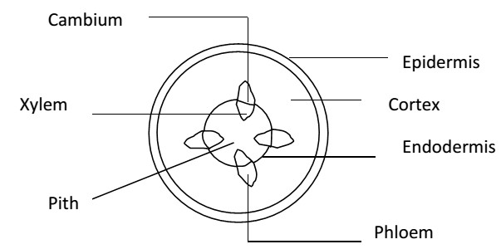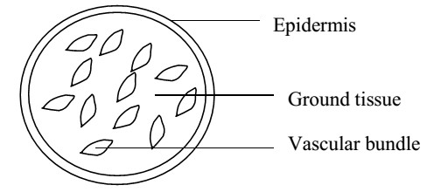

Internally stems have 3 main tissues; 1. Epidermis
It comprises of a single layer of cells which are brick-shaped. The outer wall of these cells is thickened by cutin, a waxy material which forms the outside skin of a stem called cuticle.
- It protects the stem against water loss.
- It also protects the inner tissues of the stem from mechanical injury.
- It prevents entry of bacteria and germs into stem.

2. Cortex
This is the part of the stem between the epidermis and the vascular bundles. It’s made up of collenchyma, parenchyma and endodermis.

i) Collenchyma
This is the outer tissue of the cortex. It’s 3 or more cells thick. The cells are small, tightly packed and thickened at their corners. They offer mechanical support, hence strengthening and giving rigidity to the stem.

ii) Parenchyma
This is made up of large thin walled cells. These cells have air spaces between them called intercellular spaces. The spaces provide passage for water vapour and gases in the stem. Parenchyma cells offer support to the stem when filled with water and store some food.

iii) Endodermis
This is a single layer of rectangular shaped cells. It contains starch usually, and its main function is storage of food.

3. Vascular bundles
These are conducting or transporting tissues of a plant. They consist of xylem and phloem. The phloem lies externally and the xylem lies internally in each bundle.
Phloem:
The phloem conducts and transports manufactured food. It is made up of three main cells:

i) Sieve tubes
These are cylindrical tubes arranged end to end in long rows. Their cross-walls have many fine pores forming a sieve plate. They conduct manufactured food in the stem. ii) Companion cells
These are smaller than the sieve tubes. They are filled with a dense cytoplasm and have nucleus. They control the activities of the sieve tubes.

iii) Phloem parenchyma
It stores some food in the stem. They are the first to be formed in the vascular bundle.
Xylem:
Xylem is water and mineral salts conducting tissue. It comprises of 2 types of cells i.e. vessels and tracheids. These cells have their walls thickened with a substance called lignin.
The xylem also provides mechanical strength to the stem due to the presence of lignified dead cells. The lignified dead cells formed between the endodermis and phloem is termed as sclerenchyma.

Differences between dicot and monocot stems
Monocot stem | Dicot stem
Lack cambium | Has cambium. The cambium is responsible for secondary growth or thickening of the stem.
The vascular bundles are scattered within the stem. | The vascular bundles are arranged in form of a ring.
Lack a distinct cortex and pith. | Has a distinct cortex and pith. The pith is wide.
Its cortex has several layers of parenchyma cells. | Its cortex has a few layers of parenchyma cells.

LEAVES
A leaf is a thin flattened structure which grows from the nodes of a stem or its branches and has a bud in its axil. Leaves are generally green although some are red or brown. The leaf is made up of 3 main parts;

External structure of a leaf

Dicot leaf
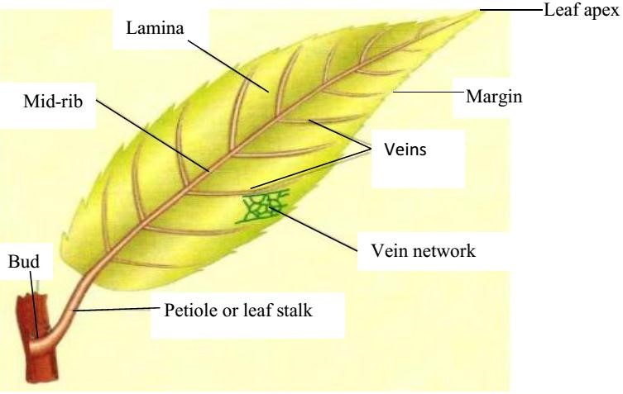

The monocot leaf
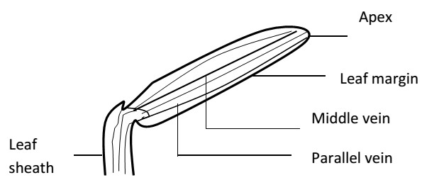

Leaf base; this is the part which attaches the leaf to the stem.
Petiole; this is the part which connects the leaf base to the leaf blade. Leaves with a petiole are called petiolate and those without are called sessile.
The leaf stalk is a characteristic of dicots while a leaf sheath is found in monocots. The leaf stalk/sheath can be hairy or smooth.
Lamina; this is the expanded and flattened portion of the leaf consisting of veins and midrib. Texture of lamina; the lamina may be hairy or smooth. It may be hard or soft.

Venation
The arrangement of veins in the lamina of a leaf is called venation. Two broad types of venation are;
- Network venation/reticulate venation
In network venation, the veins in the lamina branch while intersecting to form a network. It’s a characteristic of dicots.
- Parallel venation
In this venation, the veins run side by side without branching. This is a characteristic of monocotyledonous plants.

Leaf complexity
Leaves can be classified according to whether the leaf lamina is completely divided or not divided. Two broad types are:
Simple leaves
Compound leaves

1. Simple leaves
A simple leaf has a single lamina which isn’t divided up into leaflets e.g. Avocado, mango, orange, hibiscus, pawpaw, cassava, etc. Cassava and pawpaw leaves are partly divided. The lobes are not considered to be leaflets because the divisions do not reach down the midrib. They are simple digitate i.e.
Simple leaf of a mango

Simple leaf of cassava

A swelling at the base of the leaf stalk is called pulvinus e.g. beans and cassava. Some leaves have it while others do not have it.

2. Compound leaves
A compound leaf has a lamina which is completely divided into leaflets. They resemble leaves but are not leaves because the axillary buds are absent in the axis of leaflets e.g. beans, oxalis, cassia, etc.

Types of compound leaves
i) Compound pinnate leaves  These are compound leaves with leaflets arranged either in pairs opposite one another or alternately along the midrib called rachis of the leaf. If the terminal leaflet is present, the leaf is said to be imparipinnate and if the terminal leaflet is absent, the leaf is said to be paripinnate. | Imparipinnate  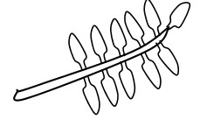 | Paripinnate  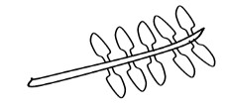
ii) Compound bipinnate leaves  These are compound leaves with 2 orders of leaflets. Leaflets are further divided up to form leaf-like structures called pinnules e.g. jacaranda. | 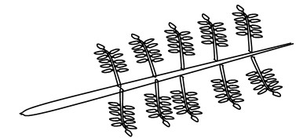
iii) Compound digitate leaves  These are compound leaves with leaflets radiating out from the end of the petiole-like fingers of the hand. | 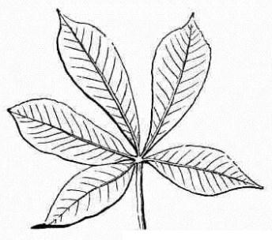
iv) Compound trifoliate leaves  These are compound leaves with only 3 leaflets. They include soya beans, oxalis and straw berry. | 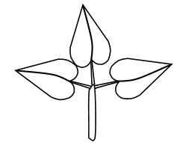

NB: stipules (foliar appendages) are attached to the leaf base or petiole e.g. in beans, hibiscus and cassia.

INTERNAL STRUCTURE OF A LEAF
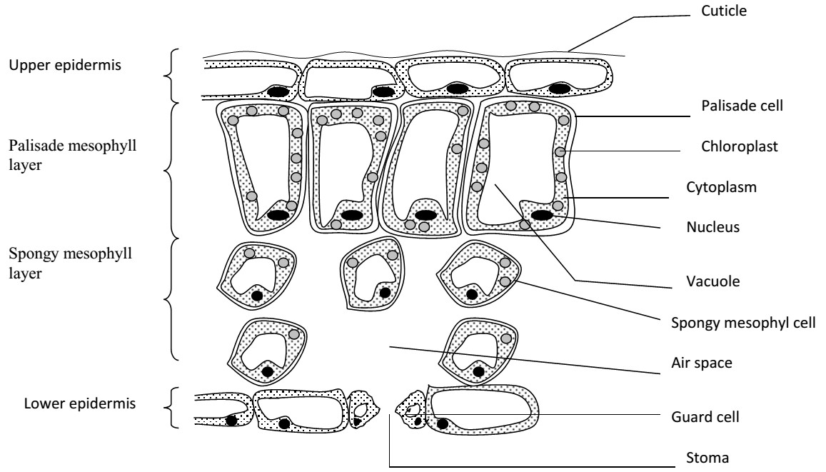
1. Epidermis:
This is the outer most layer of a leaf. It acts as a skin covering the whole leaf surface. It’s covered by a transparent water porous layer of cutin called cuticle. This cuticle allows light penetration into the leaf and prevents excess water loss from the leaf surface.
The epidermal tissue is divided into 2 according to the location on a leaf i.e. upper and lower epidermis. The upper epidermis is a single layer of brick-shaped cells covered by a thick cutin in case of terrestrial plants or land plants. In most plants, it does not possess stomata and if present are few. This is so as to control the amount of water loss during transpiration process.
The major function of this epidermis is to prevent evaporation of water from the leaf cells and protection of the inner cells.
The lower epidermis is usually made up of one layer of cells and contains numerous openings called stomata. These stomata are protected by 2 guard cells. In water plant e.g. water lily or hyacinths, stomata are few on this side of the leaf. Some chloroplasts are present in this layer of cells.

Stomata
These are small openings found in the epidermis of a leaf. They are surrounded by 2 guard cells. Plants growing on land have more stomata located in the lower epidermis than in the upper epidermis. (The reverse is true for aquatic plants)
The function of the stomata is to allow entry and exit of important gases like O₂ and CO₂ into the leaf.
The stomata also regulate the loss of water vapour from the plant i.e. they control transpiration.

Structure of the stomata
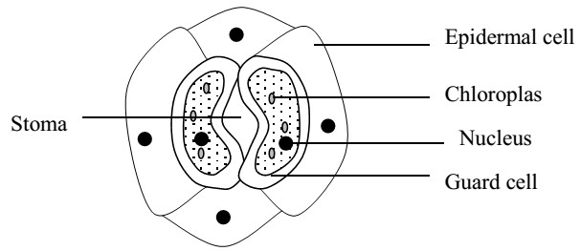
2. Mesophyll:
This is located between the upper and the lower epidermis. It’s differentiated into two layers. i.e. i) Palisade layer
It’s found just below the upper epidermis. It’s made up of cylindrical shaped cells. The cells are closely packed together without air spaces. The palisade cells contain many chloroplasts which are the major sites for photosynthesis.
Chloroplasts are small and made up of proteins. They contain chlorophyll which gives green plants their colour. The chlorophyll absorbs sun light energy that is used in the process of food manufacture (photosynthesis).

ii) Spongy mesophyll layer
It’s found under the palisade layer. It consists of cell called spongy cells which are irregularly arranged. These cells are not closely arranged, and therefore have large intercellular air spaces between them. The air spaces are connected with each. There is also the sub-stomatal air chamber where the gases collect before moving out of a leaf. Spongy cells contain fewer chloroplasts than the palisade cells hence they manufacture food.

3. Vascular tissue
These are vascular bundles consisting of veins. Each vein has a phloem for transporting manufactured food and the xylem for conducting and distributing water and mineral salts. The veins also provide mechanical support to the leaf lamina.

Arrangement of leaves on a stem
Arrangement is the insertion of leaves on the stem. Leaves develop at the nodes in the stem and are arranged in different ways.
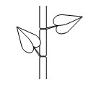Alternate leaf arrangement | 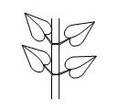  Opposite leaf arrangement | 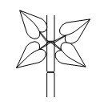  Whorl leaf arrangement
Types of leaf margins Leaves can be classified according to the leaf margins.

1. Entire margin
The margin is smooth and without indentation of 4. Dentate margin
any kind. E.g. mango leaves. The margin has indentations pointing towards the
- Serrate margin petiole.
The margin is with indentations pointing towards 5. Lobed margin
the apex. The margin has relatively few and shallow
- Crenate margin indentations.
The margin has round indentations.

Types of leaf shapes
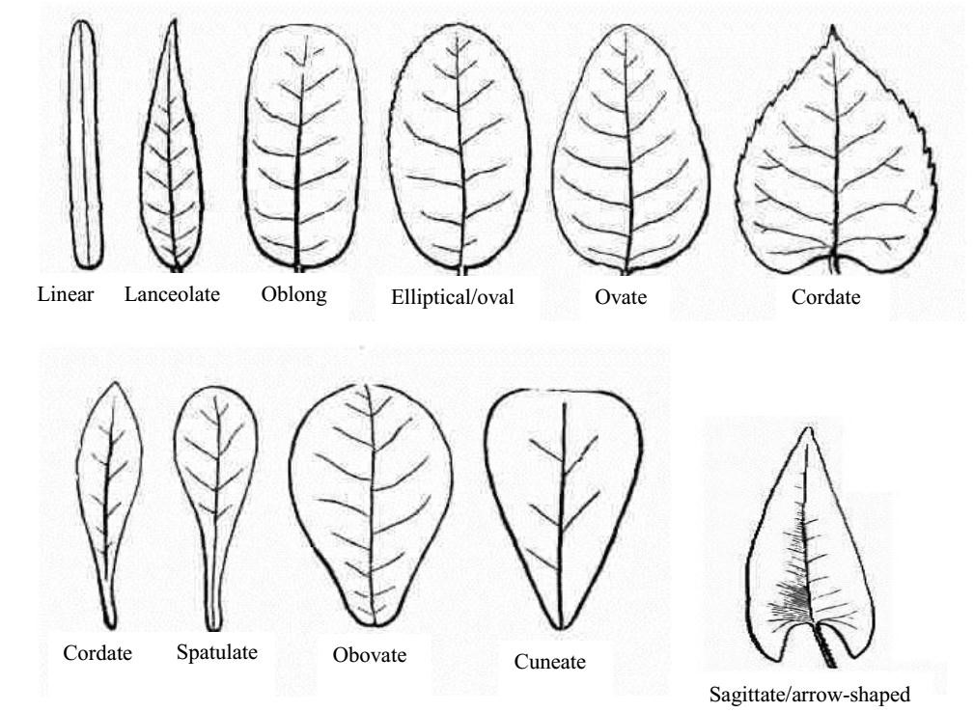
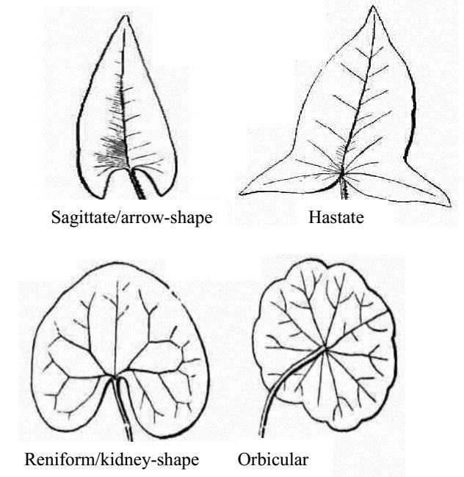

Functions of leaves to plants a) Primary functions
- The major function is to manufacture food for the plant during photosynthesis.
- Leaves have stomata which allow exchange of gases i.e. O₂ and CO₂.
- Leaves facilitate transpiration which sometimes helps the removal of excess water within the plant.

b) Modified or secondary functions
- They store food and water for the plant e.g. the thick fleshy leaves of onions.
- Some plant leaves are useful in vegetative reproduction e.g. bryophytes.

Modification of leaves
Leaves of some plants have become modified to perform other functions other than photosynthesis. 1. Leaf tendrils
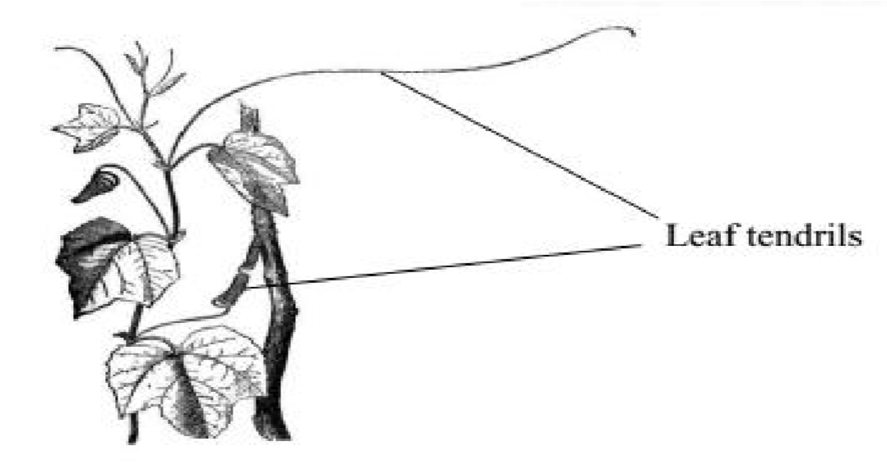
These are slender wire like coil structures used as climbing organs in climbers for support. The leaf may be partly modified into a tendril.

2. Leaf spines
These are sharp pointed structures of certain plants modified for defense.

3. Scale leaves
These are thin, dry membranous structures usually brown in colour and sometimes colourless. Their main function is to protect the axillary bud from mechanical injury and drying out. They are commonly found on underground stems. E.g. scale leaves of onions, rhizome and garlic.

4. Insectivorous leaves
These are modified leaves whose function is to capture and digest insects. Such plants are called insectivorous plants.
Pitcher plants grow in soil with a deficiency of nitrogen/nitrates. They obtain nitrogen from insects. E.g. Venus fly trap, butter wort, sundew, bladder wort, nepenthes, and the pitcher.

5. Bryophyllum leaves
Leaves have series of buds at the end of vein. These buds grow into new plants (plantlet) when the leaf is mature.
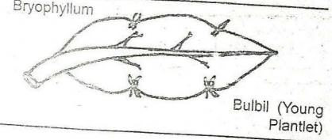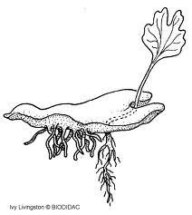

THE FLOWER
The flower is part of the shoot specialized for reproduction. Most flowers have male and female reproductive organs though some are of a single sex. A group of flowers is called an inflorescence e.g. maize flower.

General structure of a flower
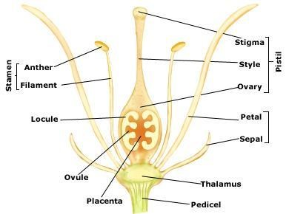

When petals, calyx, epicalyx and the sheath of the staminal tube have been removed, this is shown in the diagram Parts of a flower
The floral parts are arranged in rings, spirals or whorls with short internodes. The end of a flower stalk may be expanded to form a receptacle. The stalk of the flower where floral parts grow is called pedicel.
The four floral whorls are Calyx, Corolla, Gynoecium and Androecium.
The calyx is the outer most floral whorls of the flower made up of sepals. The calyx protects the inner whorls of a flower during the bad stage.
The corolla is the second floral whorl of a flower made up of petals. Most flowers have scented petals to attract insects for pollination e.g. hibiscus, crotalaria, coffee, morning glory, etc. the calyx and corolla are collectively known as Perianth.
Androecium is the male part of the flower consisting of stamen. Each stamen is made up of filament and head called anther. Anthers contain pollen grains which develop to form male reproductive cells called gametes. N.B: an infertile or sterile stamen is called staminode.
Gynoecium (pistil) is made up of female reproductive parts called carpels. The pistil occupies a central position in the flower. Each carpel is made up of;
- Ovary which contains ovules or female gametes.
- Style which connects the ovary to the stigma
- Stigma which receives the pollen grains
The wall of the ovary develops into the pericarp of the fruit. Nectaries are swellings often at the base of the ovary or on the receptacle which produce a sugary solution called nectar.

Types of pistils Three main types of pistils are:
- Monocarpous: This is a pistil with only one carpel e.g. morning glory and cow pea.
- Syncarpous pistil: This is a pistil with carpels fused together e.g. hibiscus and isolanum.
- Apocarpous pistil: This is a pistil with several carpels which are not fused i.e. as distinct carpels e.g butter cap and Bryophyllum.

Types of ovaries
The two types of ovaries include the following
- Superior ovary: Is the one that arises above the other floral parts e.g. hibiscus, cassia, commelina, mimosa pudica, etc.
- Inferior ovary: Is the one which arises below the rest of the floral parts e.g. morning glory.

Hypogenous: The gynoecium is situated at the apex of the receptacle and other whorls arise below it. The sepals and petals are inserted independently below gynoecium. Hypogenous flower has superior ovary.

Terms used
Complete flower: A flower having all the four whorls or floral parts i.e. calyx, corolla, stamen and pistil.
Incomplete flower: A flower lacking one or more of the four floral parts.
Perfect flower: Is a flower with both male (stamen) and female (pistil) parts.
Imperfect flower: A flower lacking either stamen or pistil.
Unisexual flower: Has only one of the sexual parts i.e. staminate; when the flower has stamens only. Pistillate (carpellary) when it has carpels only.
Staminode: sterile stamen.
Bisexual (hermaphrodite) flower: is one that contains both male and female organs and parts.
Monoecious plant: Is one that has the pistillate and staminate that are born on the same plant but at different points on the plant e.g. maize and castor oil plants.
Dioecious plant: is one that bears either pistillate or staminate flower only e.g. pawpaw.
Dichogamy: Is a condition in which the male and female parts of a flower mature at different times. There are 2 types;
- Protandry: when the anthers mature before the stigma.
- Protogyny: where by the stigma matures before the anthers.
Regular (actinomorphic) flower: a flower which can be divided symmetrically (equally) in different planes.
Irregular (zygomorphic) flower: is one which can be divided into 2 similar halves in only one plane.
Polysepalous: is when the sepals are borne free or are separate and are distinct from each other.
Gamosepalous: is when the sepals are fused or joined together.
Petaloid: Sepals resembling petals and have the same colour.
Gamopetalous: Are petals which are wholly joined or fused together e.g. morning glory, sweet potatoes.
Sepaloid: They are petals which resemble sepals and are green in colour.
Septum: Is an internal dividing wall or partition with in a syncarpous ovary.
Locules: Is an internal compartment of an ovary of fruits.
Simple flowers may be borne on a common flower stalk called peduncle while individual flowers may be borne on a pedicel.

POLLINATION
Pollination is the transfer of pollen grains from the anther to the stigma of a flower. There are two types of pollination.
- Self-pollination. This is the transfer of pollen grains from the anther to the stigma of the same flower or between two flowers on the same plant.
- Cross-pollination. This is the transfer of pollen grains from the anthers of one flower to the stigma of another flower on a different plant but of the same species.

Agents of pollination
These are things that aid the process of pollination. The agents of pollination include.
Animals, Water, Wind and Artificial pollination
There are however two major agents that is wind and insects. Pollination can therefore be described as wind pollination and insect pollination.

Characteristics of insect pollinated flowers
i) They have brightly coloured petals to attract insects. ii) They have a scent to attract insects
iii) They have large conspicuous petals, which act as landing sites for insects. iv) They have sticky pollen grains, which stick to the insects’ body. v) They have sticky stigmas, which hold pollen grains.
vi) They produce few sticky pollen grains. vii) They produce heavy pollen grains. viii) They produce nectar from nectarines to attract insects.

Characteristics of wind pollinated flowers.
- They have dull coloured petals.
- They have small petals. iii) They produce light pollen grains, which can easily be carried by wind.
- They do not produce nectar
- They have feathery stigmas to trap pollen grains carried by wind.
- They produce a lot of pollen grains. vii) They have no scent
viii) They have long stamens and pistils hanging outside the petals to release and receive respectively pollen grains easily.

Differences between insect and wind pollinated flowers.
Insect pollinated flower | Wind pollinated flower
Have brightly coloured petals | Have dull coloured petals
Have a scent | Have no scent
Produce nectar from nectarines | Produce no nectar
Have large petals | Have small petals
Produce few pollen grains | Produce a lot of pollen grains
Have sticky stigmas | Have feathery stigmas
Produce heavy pollen grains | Produce light pollen grains
Have short pistils | Have long pistils
Have short stamens | Have long stamens

Characteristics of flowers pollinated by nocturnal insects
Nocturnal insects are those insects, which are active at night. Flowers pollinated by such insects have the following characteristics.
- They have light coloured petals mainly white and pink.
- They produce a strong scent.
- They open their petals at night and close them during daytime.

Modifications of flowers to prevent self-pollination
- Protandry. This is a situation where stamens ripen before the stigma such that when pollination occurs, the pollen grains cannot germinate on the immature stigma.
- Protogyny. This is a condition where the stigma ripens before the anthers.
- Dioecious condition. This is a condition where a plant bears either pistillate or staminate flowers but not both.
- Self-incompatibility. This is where pollen grains from the same flower fail to fertilize the stigma of that flower.
- Structure of the flower. Sometimes the carpel is taller than the stamens of the same flower and in some flowers the corolla covers the stamens preventing self-pollination.

FERTILIZATION IN PLANTS
This is the fusion of male and female gamete to form a zygote. Fertilization in plants is internal taking place inside the ovary in the structure called embryo sac.

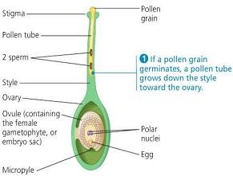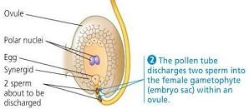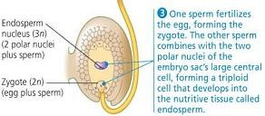
The pro
cess of fertilization in plants

1.

Pollen grain lands on the stigma of a flower of
the same species.

2.

On the stigma, pollen grain absorbs water,
nutrients and then
germinates to form a pollen
tube which grows through the style under the
control of the tube nucleus at the tip.

3.

Pollen grain has two nuclei i.e. generative
pollen
The
nucleus.
tube
and
nucleus
generative nucleus divides mitotically to form
two male nuclei

which lie

behind the pollen tube
nucleus
.

4.

The pollen tube enters the ovary and the tip of
the pollen tube breaks. The pollen tube nucleus
disappears.

5.

One of the male nucleus fuse with the egg nucleus
to form a zygote which divides mitotically to

form
embryo.

6.

The other male nucleus fuses with two polar nuclei
to form a triploid endosperm which develops into
endosperm. This is called double fertilization.

Events after fertilization
- The zygote divides mitotically followed by growth and development resulting into an embryo.
- The triploid endosperm divides mitotically to form good solid organs called endosperm.
- The ovules develop into seeds.
- The integuments become the seed coat.
- The ovary develops into a fruit and ovary wall develops into a fruit wall which protects the seeds.
- Petals, stigma, style and stamen wither and fall off while the calyx may wither and fall off or may remain in shriveled form.

SEEDS
A seed is a fertilized mature ovule. It has one scar called hilium which is a spot where it was attached to the pod inside a fruit.
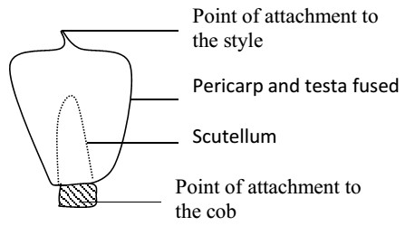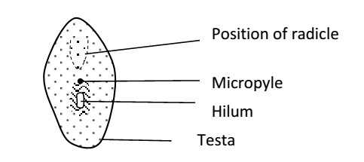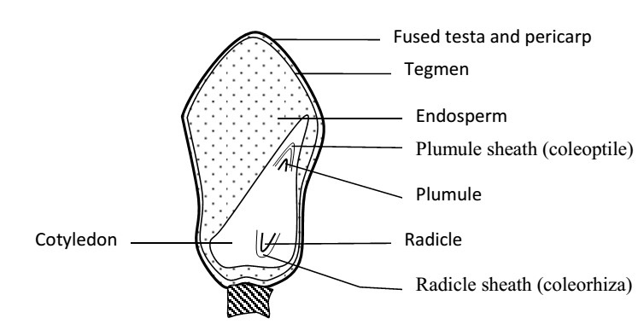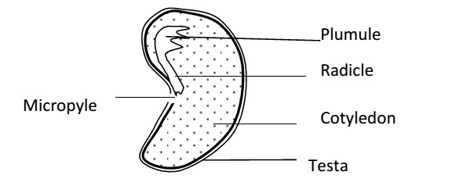
Types of seeds

Monocotyledonous seeds
:

These contain only one seed leaf or
cotyledon. E.g. cereals like maize.

External structure of a monocot se
ed

Dicotyledonous seeds:
These contain 2 cotyledons
e.g.
legumes like beans, peas and G. nuts.

External structure of a seed (dicot seed)

Internal structure of a
monocot seed (
maize seed
)

Internal structure of a dicot seed

i) Testa
It is a protective -covering of the embryo of the seed formed from the integuments. It is usually hard and dry. It protects it from fungi, bacteria and insects. ii) Tegmen
It is the inner membrane of the seed coat and it’s also used for protection.

iii) Micropyle
It is a narrow opening into the seed through which water, mineral salts and oxygen enter during germination. iv) Radicle
It is a seed root (embryo root) which develops into primary root of the plant. A developing root has a root cap which bores through the soil particles and protects the newly formed cells at the root tip from mechanical damage. v) Hilium
It’s a scar of attachment left by the stalk of the ovule to the ovary wall. vi) Endosperm
Stores food especially starch for the embryo. vii) Scutellum or cotyledon
Digests and absorbs food stored in the endosperm. It provides food to the whole seed. viii) Coleorhiza
It is the radicle sheath that offers protection to the radicle. ix) Coleoptile
It is the plumule sheath that offers protection to the plumule. x) Cotyledon
These contain stored food like starch, proteins and liquids for the initial growth of the embryo during germination.

FRUITS
A fruit is a fully grown fertilized ovary containing one or more seeds. A fruit has 2 scars, one where it was attached to the receptacle and the other, the remains of the style or stigma.
During a fruit formation, the wall of the ovary becomes a fruit wall called pericarp. In some fruits such as banana and pine apple, the fruits develop without fertilization. Such fruit are said to be parthenocarpic fruits. Therefore parthenocarpy is the development of fruits without fertilization.

CLASSES OF FRUITS
True fruits: develop only from the ovaries of a flower e.g. beans, tomatoes, etc.
False fruits: develop from the association of ovaries and other floral parts such as receptacle. Examples include; pineapples and apples.

Classification of fruits There are 3 groups of fruits namely; i) Simple fruits
These are formed from one flower in which the pistil consists of either one carpel (monocarpic) or of several fused together (syncarpous) e.g. legumes, g, nuts, peas, tomatoes, mango, beans, etc. ii) Aggregate fruits
These are formed from one flower in which the pistil consists of several free carpels (apocarpous) e.g. apples and rose. iii) Multiple fruits
These are formed from several flowers and the ovaries become fused after fertilization e.g. jackfruit and pineapple. SIMPLE FRUITS
There are either dry or succulent according to whether the pericarp becomes dry or juicy as the fruit ripens. Types of simple fruits Simple fruits are further divided into three categories.
1. Dry indehiscent fruits 2. Dry dehiscent fruits 3. Succulent fruits.

Dry indehiscent fruits
These are fruits with a dry pericarp that does not split up (dehisce) to release seeds. This category contains five types of fruits. These are Achene, Nut, Caryopsis, Cypsela and Samara.

The table below shows the different types of dry indehiscent fruits.
Type of dry indehiscent fruit | Description | Illustrative diagram
Achene | This is a one seeded fruit covered by a dry pericarp, which does not split open, e.g. sunflower. The achene is the simplest fruit. | An achene of sunflower.  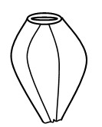
Nut. | This is similar to an achene but the pericarp is hard and tough, e.g. cashew nut. Note; coconuts and groundnuts are biologically not nuts. | 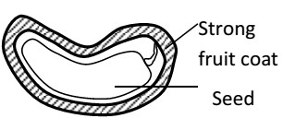  Section through a cashew nut
Caryopsis. | This is an achene-like fruit in which the testa and pericarp are fused. These are mainly found in grasses and maize. | Caryopsis of maize.  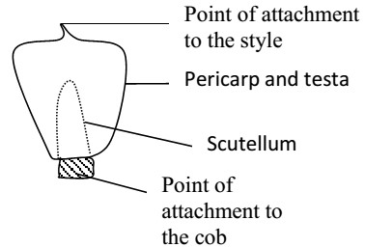
Cypsela | This is a fruit similar to an achene in which the inferior ovary has a pappus of persistent calyx. It is common in composite fruits, e.g. tridax and bidens pilosa | Cypsela of tridax.  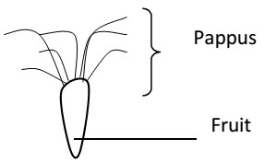
Samara. | This is a fruit similar to an achene in which the pericarp is extended to form one or more wings, e.g. in jacaranda and African rose wood. | Samara of jacaranda.  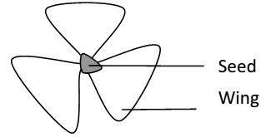

Dry dehiscent fruits
These are fruits with a dry pericarp that splits (dehisces) to release seeds. The fruits split at particular lines of weakness known as sutures. These fruits are categorized into the following different groups depending on the number of splits that occur on the pericarp. These fruits include, Follicles, Legume, Capsule and Schizocarp.

The table below shows the different types of dry dehiscent fruits
Type of dehiscent fruit | Description | Illustrative diagram
Follicle | This is a dry fruit with many seeds and splits open along one suture, e.g. Sodom apple | 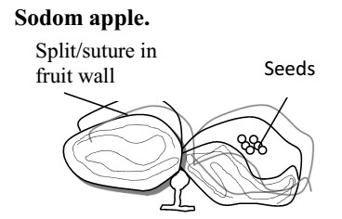
Legume. | This is a dry fruit with many seeds and splits open along two sutures, e.g. beans, peas, flamboyant and Barbados pride. | Legume of a bean  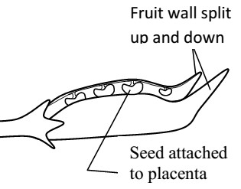
Capsule | This is a dry fruit with many seeds and splits open along many vertical slits. It is formed from an apocarpous flower, e.g.  Dutchman’s pipe, balsam, cotton, etc. | 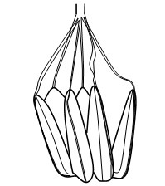
Schizocarp. | This is a dry several seeded fruit, which breaks up into  Separate parts each containing one seed, e.g. desmodium, sweet hearts and some cassia. | 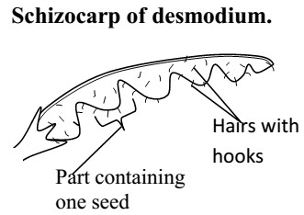

Succulent fruits
These are fleshy fruits. They are either entirely fleshy or have part of it fleshy. They are further divided into 2 types.
- Drupes.
These are fruits with only one seed and only part of it fleshy (epicarp and mesocarp). The endocarp is fibrous and hard, e.g. mango and avocado.
Longitudinal section through a mango.

- Berry.
This is a fruit with many seeds and the whole of it fleshy, e.g. tomatoes, guavas, oranges, bananas etc.
A transverse section through a berry (orange)

3. Pome
This is a succulent fruit in which the outer fleshy (normally edible) part develops from the calyx and receptacle. The ovary forms a papery cover containing seeds e.g. apple and pears.

PLACENTATION
This is the distribution of the placentae in the ovary or the arrangement of the seeds on the placenta within the ovary. There are five types of placentation as shown in the table below.
Type of Placentation | Description | Example
Marginal | Ovules are situated at or near the margin of the ovary | Beans, peas, cassia
Axile | Ovules centrally located in the ovary with ovary divided into many chambers. | Orange and tomato
Central | Ovary is one chambered and ovules centrally located | Soap wort,
Parietal | Placenta is found on the inner wall of the fruit and the ovules are attached on the inner wall | Passion fruits pawpaw, cocoa
Free central | Ovules located on the projection from the base of a one chambered fruit | Green pepper
Basal | Ovule found on a placenta that arises from the base of the ovary, fruit usually single seeded | Mango, avocado.

FRUIT/SEED DISPERSAL
This is the scattering or spreading/displacement of fruits and seeds from their parent plants. In some plants, only seeds are dispersed while in others, fruits are dispersed with seeds.

Importance of dispersal
i) It helps to prevent overcrowding among plants of the same species. ii) It reduces competition between member plants of the same species. iii) It helps to minimize the spread of epidemic diseases especially in seedlings if they are crowded. iv) It helps plants to colonize new areas which may even be better for the species survival. v) It enhances the chances of survival and continuity of the plant species. Agents of dispersal include the following:
- Water,
- Wind
- Animals
- Self-dispersal/ explosive mechanism
Fruits and seeds possess specialized structure to aid their dispersal and are adopted to specific mode of dispersal.

Characteristics of fruits/seeds dispersed by wind
- They are usually small, light and dry which enables them to easily be carried or flown by wind.
- Some fruits like elm and tecoma have wing like structures that increase their surface area. This helps in delaying the fall of seeds and fruits and increases chances of being blown away.
- Some fruits like tridax and clancletion have parachute-like hairs called pappus which enables them to fleet and fly by wind.
- Some seeds like silk cotton possess thread-like structures called floss which increase surface area enabling the seeds to float in air.

Characteristics of fruits/seeds dispersed by water
i) They are usually light and contain air space inside which reduces their relative density that enable them float on water easily like the coconut.

Characteristics of fruits/seeds dispersed by animals
- Some fruits such as tomatoes, oranges and mangoes are usually large and brightly coloured especially when ripe. This helps to attract animals.
- Some fruits when ripe are scented e.g. jack fruit. This helps to lure/attract animals. iii) Some usually possess edible parts which are succulent / juicy and the only part of the fruit that is eaten and the rest containing the seeds is thrown away e.g. mango and avocado.
- In some fruits, such as guavas, tomatoes, pepper and pawpaw. The whole fruit is eaten and the seed passed out in the faeces because of their resistance to digesting i.e. are indigestible.
- Some fruits e.g. Biden pilosa and desmodium possess hooks and sticks in the hair of passing animals. They stick in the fur of animals or on clothing of people.

Self-dispersal a) explosive mechanism
This happens with dry dehiscent fruits. The pericarp splits open along the sutures to release the seeds. This is made possible due to the tension that is built during the process of dying. E.g. legumes, capsule or follicles b) ribbon fruits
These are succulent, may drop freely from the parent plant. The pericarp then rots, bearing the seeds that are enclosed within a hard protective testa so that it can begin germinating.

SEED GERMINATION
This is the growth and development of an embryo of a seed into a seedling or a young plant under favorable conditions.

Types of germination 1. Epigeal germination
This is where the cotyledons appear above the ground due to the rapid elongation of the hypocotyl e.g. beans, cotton, sun flower, etc.

2. Hypogeal germination
Is where the cotyledons remain below the ground and the radicle emerges due to elongation of the epicotyl e.g. maize, mango and black jack.
NB: During germination, the seed absorbs water mainly through the micropyle which makes the cotyledon swell and split the testa. This process is called imbibition. The radicle comes out of the testa faster followed by the plumule.

Conditions necessary for germination to occur a) Environmental or external factors
i) Water ii) Oxygen iii) Suitable temperature

b) Internal conditions
i) Viability of the seeds ii) Amount of food in the seeds
- Enzymes
- Absence of germination inhibitors e.g. poison

1. Water
Water is needed for the following:
- It activates the enzymes within the seed to hydrolyze the stored food.
- It makes the seed swell, soft and the testa to bursts.
- It dissolves the stored food.
- It is a medium in which all the chemical and enzymatic reactions proceed.
- It is a medium of transport of the dissolved food substances to the developing shoot and root of the new plant.
- Water is needed for the development of cell vacuoles. Large cell vacuoles contribute to increase in size of cells.

2. Oxygen
Oxygen is necessary for the process of respiration, the oxidation of food to provide energy required for growth.

3. Warmth
Suitable temperature is important for the enzyme controlled reactions in the cotyledon of the germinating seed. At low temperatures, the enzymes are inactive and at high temperatures, they are denatured hence no germination. Germination will require an optimum temperature which varies from 10̊C-50̊C for most tropical seeds.

An experiment to demonstrate the conditions necessary for germination Apparatus:
4 test tubes, Cotton wool, Seeds, Oil and Water.
Procedure:
- Arrange four test tubes labeled 1-4
- To test tube 1 add moist cotton wool, seeds and leave test tube open.
- To test tube 2 add dry cotton wool, seeds and leave test tube open.
- To test tube 3 add seeds, boiled cooled water and a layer of oil.
- To 4 add seeds, moist cotton wool, and ice and leave test tube open. Leave all test tubes for 3 days. Setup:
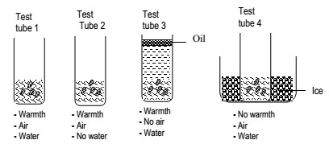

Observations
Seeds germinated in only test tube 1 and those in 2, 3 and 4 did not germinate.
Conclusion:
Air, water and warmth are necessary for germination.

Experiment to show that oxygen is necessary for germination Apparatus:
2 conical flasks, 2 corks, Water, Cotton wool, Seeds and Pyrogallic acid.
Procedure:
- 1. Pour some water in one conical flask and some alkaline pyrogallol in another conical flask.
- Tie some seeds in wet cotton wool and suspend the cotton wool in the flasks using a thread. ✓ Fix the threads using a cork. ✓ Leave the set up for three days Set up:
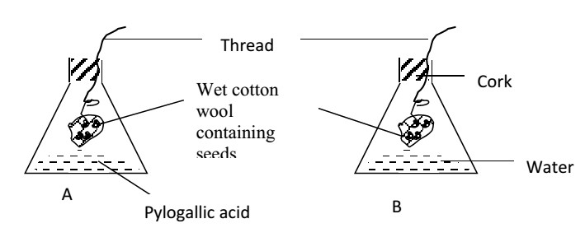
Observation:
After a few days the seeds in B germinated while those in A did not germinate.
Conclusion:
Oxygen is necessary for germination.
Explanation:
Alkaline pyrogallol absorbs oxygen from air in flask A thereby preventing germination.

SEED DORMANCY
Seed dormancy is the condition where by viable seeds fails to germinate under certain conditions or resting stage. Causes of seed dormancy

1. Immature embryo of the seed
This may cause dormancy in seed germination since the embryo may undergo development before germination occurs.

2. Presence of germination inhibitors
Some chemical substances like acids do not promote germination of seeds when present. They destroy the enzymes.

3. Extreme temperatures
These greatly affect the working of enzymes in the seed. High temperatures denature enzymes while low temperatures inactivate them.

4. Presence of hard impermeable seed coat
Some seeds have a strong seed coat that does not allow water and gases to enter the seeds. Without water and gases, germination will not take place.
5. Dryness of soil and lack of sufficient oxygen enough for seeds.
If oxygen is absent, seed respire anaerobically and obtain less energy. This will not allow seeds to germinate.

Ways of breaking seed dormancy
- Harvesting mature seeds. This involves allowing embryos in seeds to develop up to maturity for certain period called after-ripening period. This allows the seed to develop fully.
- By providing growth promoters which deactivate germination inhibitors. These are chemical substances that can make inhibitors less active. They contain nutrients or hormones for proper growth.
- By exposing seeds to a cool period or chilling to initiate germination. This is common method of breaking seed dormancy in cereals.
- By providing suitable conditions of oxygen, temperature and moisture which favour germination.
- Removing the hard seed coat by:
  - Soaking seeds in water to soften it.
  - Action of fire to burn away the seed coat.
  - Passing seeds through animal gut.
  - Churning seed coat in concentrated acids.
  - Physical removal of the seed coat by using the hand or pricking or by action of bacteria in the soil.

Importance of seed dormancy
- It promotes germination of seeds during favourable conditions e.g. seeds dispersed in winter remain dormant in summer.
- It improves the chances of seedling to grow to maturity during favourable conditions.
- Dormant seeds can be stored for a long time and the seed dormancy can be broken by giving artificial conditions. This helps in their transportation.
- It reduces the risk of seeds being frozen to death during unfavorable conditions.

